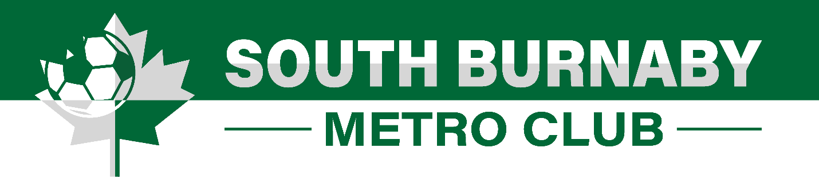
Fall & Winter Programs

- Fall & Winter Regular Season
- Starts in September until March
- Players assigned to a team with the same age group.
- Practice once on weeknight and a game on Saturday
- Trained by our volunteer coaches.
- Focused on team game and having fun playing as a team.
- Fall & Winter Monday Night Academy
- Fall – starts in September until December
- Winter – starts in January until February.
- Training every Monday night at Byrne Creek Secondary turf
- Trained by our Technical Team (paid coaches) with the direction of our Technical Director
- Training is focused on individual skills and self-improvement.
- Training in 4 different groups
    - For kids 4 years old to 7 years old
    - For kids 8 years old to 12 years old
    - High Intensity Training (selected players)
    - Goalie Training

There will be no make-up session if session is cancelled due to field closure due to weather conditions. Session schedule and time can be changed at any time. In case of any dispute, SBMC Executive Committee’s decision is final.

